Lead screw stepper based automated multilevel car parking system
MD. Shahnauze Ahsan¹, MD.Saifuddin Munna², MD Ariful Islam Bhuyan³
Department of Electrical and Electronic Engineering,
Premier University Chittagong.
Ehsan.puc16@gmail.com¹, munna.puc@gmail.com² , arif.ajtfc@yahoo.com³

Abstract—An automated car parking is a elecro-mechanical system used to minimize the area for parking cars. Since in modern world, where space has become a very big problem and in the era of miniaturization it’s become a very crucial necessity to avoid the wastage of space in big companies, markets, apartments etc. This Automatic Car Parking enables the parking of vehicles-floor after floor and thus reducing the space used. Here any number of cars can be park according to the requirement.Also the lead screw shaft based spiral lifting system make it modernized, more eficient and even a space-saving one. This paper give the information to develop a reduced working model of a car parking system for parking 16 cars within a parking area of 0.542 m². This idea is developed using Microcontroller. The aim of this paper is to develop an automated parking system prototype which will be efficient with minimum cost for densly populated cities in Bangladesh.
Keywords—Automation; Stepper; Parking;Electro-mechanical;

Introduction
Traffic jam is common phenomenon in our country especially in big cities like Dhaka, Chittagong and other divisional town area. In various densly populated cities at Bangladesh one of the most challenging and difficult issue is the management of traffic problem. As the population is increasing, the number of vehicles on the roads is also increasing leading to an insufficient area to park these vehicles. Since there is no planned parking facility in this Cities, so vehicle operators stopping their vehicles at any place whenever they need. Recently at Chittagong New Market , Govt. made a semi-automated multilevel car parking system . Inspiring this parking system we aimed to design and implement a fully automated multilevel parking system.

Literature review
The first multi-level parking system was build in 1918 for the Hotel La Salle at 215 West Washington Street in the West Loop area of Downtown, Chicago, Illinois. It was designed by Holabird and Roche. The Hotel La Salle was destroy in 1976, but the parking structure remained because it had been designated as preliminary landmark status and the structure was several blocks away from the hotel.
Various types of parking systems are available now all over the world. Here we try to illustrate some of those available systems.
Various Types of Parking System
Conventional
Semi-Autonomous
Autonomous
On street
Multifloor
Spiral Parking
Base Rotatory Parking
Pick and Place Parking
Puzzle Type parking
- Various types of parking system
[1] Microcontroller based four levels Automatic Car Parking System . Wooden structure has been used for the demonstration of this prototype. Here the elevator is a conveyor rope system which pulls up the slot and actuate by a DC motor bottom of the prototyme.
[2] Automated parking slot detection and parking system which has two gates named Entry and exit. This system not only detect the empty slot but also the control the counter system required for parking management.
[3] Microcontroller 89s52 based eight cell car parking system. Infrar-red sensors which are placed on each of the floor, to sense the cars and detect which slot is empty.Further instructions comes from the input and the DC motor runs as a parking lift model.
[4] One sided lead screw based lifting system including eight cells.This system has three different DC motor to control the X,Y and Z axis movement.
[5] This rotatory parking system based on circulating chain and sprocket. The entire parking cells rotates with the vehicles and the customer picks the empty one.
[6] RFID based platform rotatory parking system.This project is designed for automatically parking a car into the desired parking spot in a multi-floor parking lot.Lots are designed surrounding the central circular basement.There is also RFID module that will provide security as users who have authority can swap the RFID cards and get entry otherwise not.

methodology
This section consists of the overall description of the hardware of the Automated Car Parking system and details of the circuit used in the project.It also discusses the mathematical formulas or any other calculations involved in the project.

Lead Screw method

Lead screws use the helix angle of the thread to convert rotary motion to linear motion.This is one kind screw up lifting method through the shaft of the actuator.This is familiar with the conventional Archimedes' screw method .The Archimedes screw consists of a screw (a helical surface surrounding a central cylindrical shaft) inside a hollow pipe. The screw is usually turned by windmill, manual labor, cattle, or by modern means, such as a motor. As the shaft turns the bottom end scoops up a volume of water. This water is then pushed up the tube by the rotating helicoid until it pours out from the top of the tube.
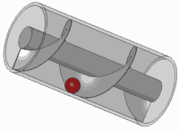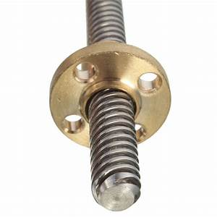

- Archimedes' screw method and Lead Screw method
We experiment the lifting up through various method but we find the precise result in this lead screw system.

Hardware
1.Drawing the basic concept in AutoCAD

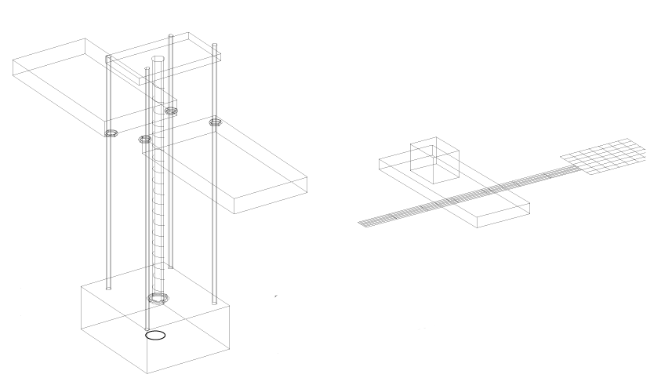

- Central lifting system design

2.Component CAD design in Solidworks

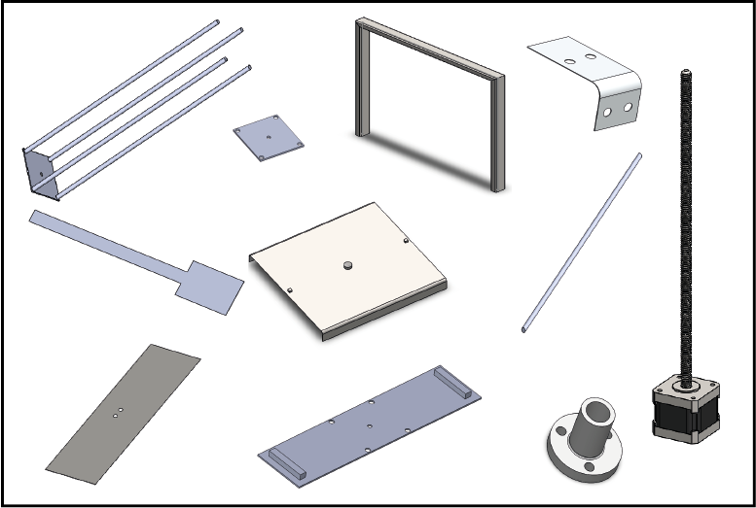

- Components CAD design

3.Components Assembly

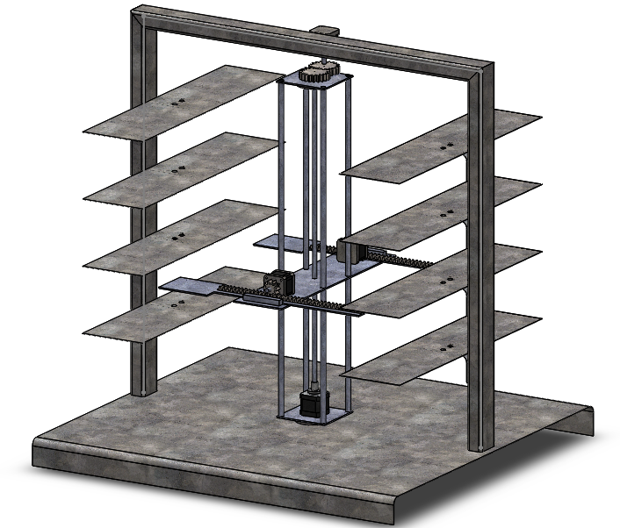

- Parking system Assembly CAD design

Software

Here we need some softwares to complete this project:
- Proteus 8 for circuit design and simulation.
- AutoCAD 2007 for basic concept design.
- Solidworks 2016 for components design and assembly.
- Arduino exe for microcontroller programming.

Algorithm
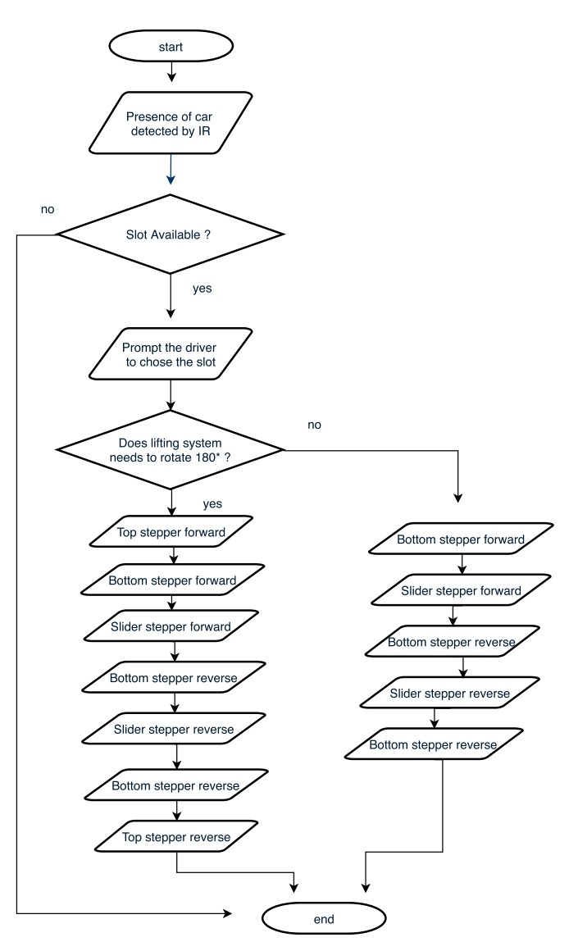

- Algorithm of parking Car
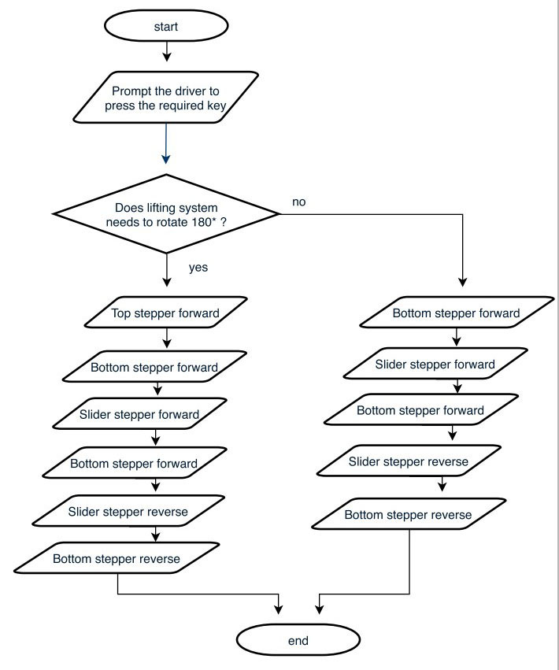
- Algorithm of retrieving Car

Schematic diagram

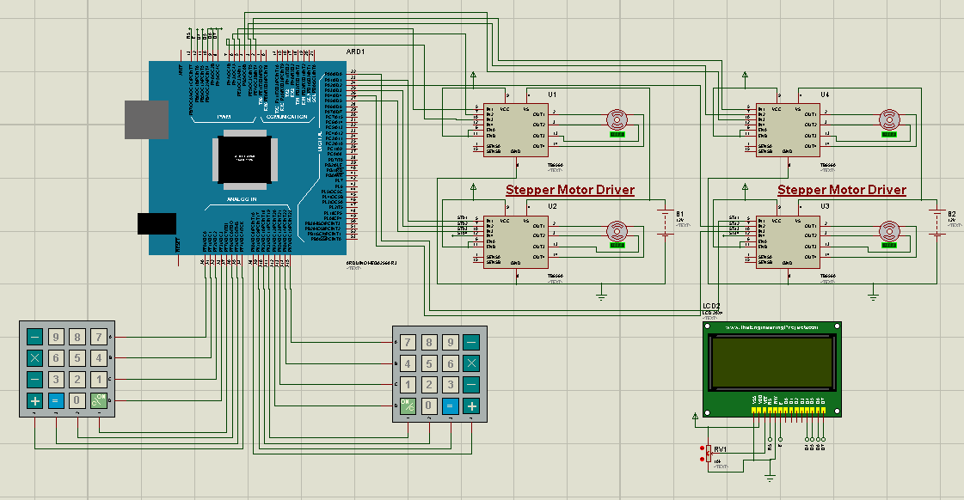

- Scematic diagram

Drawing and selection overview

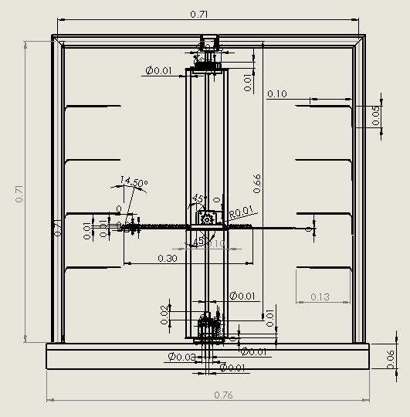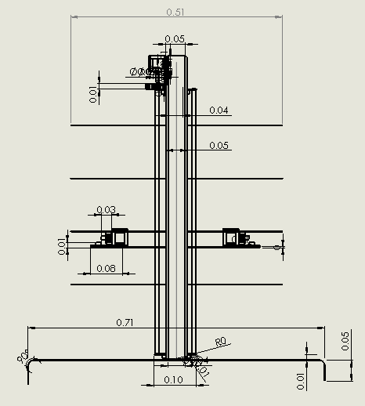

- Drawing Overview (MKS Unit system)
The performance of a lead screw depends on the coefficient of friction between the nut and the screw, which in turn depends on the material used for the nut and screw. Here’s some most important factors to consider when selecting a lead screw for an application.
- Load Capacity
- Pressure Velocity factor
- Efficiency
- Speed
- Duty cycle
- Lubrication

Implementation

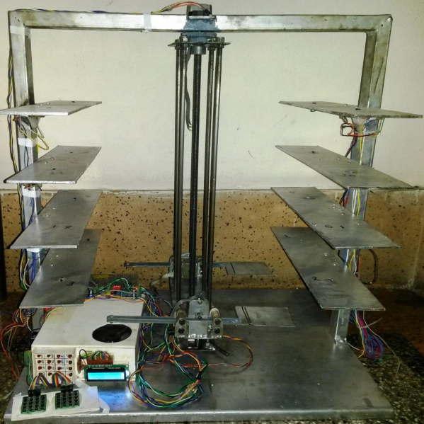

- Final Implementation

Conclusion and future scope
A successful implementation of this project would result in less traffic and chaos in crowded parking spaces like malls and business buildings where many people share a parking area. The automated parking fee system would allow people to travel without cash. It provides drivers with Also, as it would reduce the waiting time, long queues, tension, stress and increase the efficiency of the parking system. As the Smart Car Parking System Requires minimal manpower,there are minimum chances for human errors, increased security in addition to a swift and friendly car parking experience for drivers.
Some future scopes of this project are:
- PID based error detection.
- RFID based input.
- GSM and WiFi based billing system.
- IoT based Billing system

Acknowledgment
At the very beginning, we proclaim that we are very much grateful to the almighty and the most beneficent, for enabling us to complete the project work.
We are very heartful to the mechanic Uttam Barua for the weldment and proper fixing of the designed prototype.

References

- Kamrul Hassan, Md. Mustafizur Rahman and Fatema-Tuz-Zohra, ‘‘Multi-Level Automatic Car Parking With IR Card Security System,’’ International Journal of Scientific & Engineering Research Volume 3, Issue 12, December-2012
- Ganesh Sharma, Nigidita Pradhan, Tanuj KarwaI. ‘‘Design and Development of Automated Parking Slot,’’ IJECT Vol-5, Issue-1, 2014
- Ankit Gupta, Ankit Jaiswar and Harsh Agarwal, ‘‘Automatic Multilevel Car Parking,’’International Journal of Electrical and Electronics Research , Vol. 3, Issue 2, pp: (438-441), Month: April - June 2015
- V. Padiachy, J. Kumar, A. Chandra, ‘‘Development of an Automated Multi-level Car Parking System,’’ School of Engineering and Physics, University of the South Pacific, Researchgate, 2015.
- Mohummad Shariful Islam, Afshana Morshed Tithi and Farzad Hossain, ‘‘Launching Automated Rotary Parking System: Towards Traffic Congestion Free Dhaka City,’’ AIP Conference Proceedings, Volume :1919, Published : 28 December, 2017
- Vipul More1, Kiran Ravariya and Sohil Shah, “AUTOMATIC CAR PARKING SYSTEM USING RFID, ” IJARIIE Vol-3 ,Issue-2, 2017.

